**Linked list->**

* To overcome arraylist->disadvantages..

* The elements wont be connected in consecutive memory location.

*insertion is easy I .;p long chain.

* non retrival opration is used..

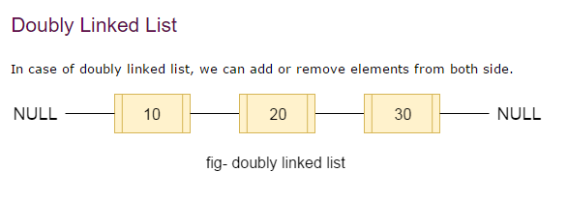

Properties->

1.doubly linked list.

2.insertion order preserved.

3.duplication allowed.

4.hetrogenous are allowed.

5.NULL can be accepted.



Collection(s)->list(s)->Linkedlist.

I have don’t implementation of stack(lifo) and queue(fifo) array and linkedlist implementation.

Note->>>>>

*usually we can linkedlust to implement stacks and queues to provide support for this requirement linklist

Class defines following specific methods->

#void addFirst(object o)

#void addFirst(object o)

#Object getFirst()

#Object getlast()

# Object removeFirst()

#object removeLast()

==================================

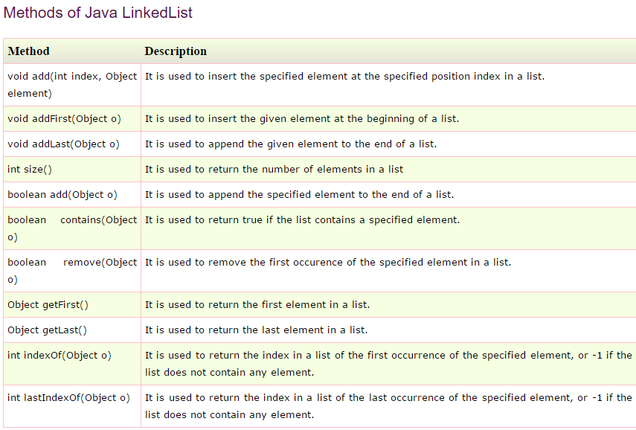

For linked listConstructors->

1.LinkedList l=new Linkedlist();//creat an empty list.

2.LinkedList l=new Linkedlist(collection c);

//creates an equivalent LinkedList Objects for the given collection.

